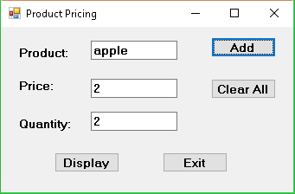 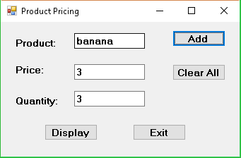

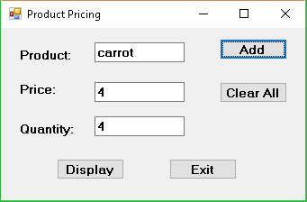

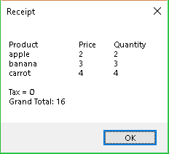

Did not have time to finish the code.

using System;

using System.Collections.Generic;

using System.ComponentModel;

using System.Data;

using System.Drawing;

using System.Linq;

using System.Text;

using System.Threading.Tasks;

using System.Windows.Forms;

namespace Product_Pricing

{

public partial class Form1 : Form

{

public Form1()

{

InitializeComponent();

}

const int MaxCount = 5;

string[] product = new string[MaxCount];

decimal[] price = new decimal[MaxCount];

int[] quantity = new int[MaxCount];

int counter = 0;

decimal grandTotal = 0, tax = 0;

private void btnAdd_Click(object sender, EventArgs e)

{

product[counter] = txtProduct.Text;

price[counter] = Convert.ToDecimal(txtPrice.Text);

quantity[counter] = Convert.ToInt32(txtQuantity.Text);

//for(int i = 0; i < MaxCount; i++)

counter++;

txtProduct.Text = "";

txtPrice.Text = "";

txtQuantity.Text = "";

txtProduct.Focus();

}

private void btnDisplay_Click(object sender, EventArgs e)

{

string totalProduct = "";

for (int i = 0; i < quantity.Length; i++)

{

if (quantity[i] == 0)

{

break;

}

else

{

grandTotal = price[i] * quantity[i];

}

}

for (int i = 0; i < quantity.Length; i++)

{

if (quantity[i] == 0)

{

break;

}

else

{

totalProduct += product[i] + "\t\t" + (price[i]) + "\t" + (quantity[i]) + "\n";

}

}

MessageBox.Show("Product" + "\t\tPrice" + "\tQuantity\n" +

totalProduct + "\n" +

"Tax = " + tax + "\n" +

"Grand Total: " + grandTotal, "Receipt");

}

}

}